Life Skills 101

The Ten core Life Skills as laid down by WHO are: 2
The Ten core Life Skills as laid down by you 2
Handy Kits 2
The Boxes of Life 3
Safe words for danger 4
First Aid 5
Your basic first aid kit 6
Have a cigarette or I’ve been promised $10,000 if I don’t smoke 6
Take Drugs or get $20,000 7
Applying for a job 8
Greeting people 9
Other people to greet 11
Avoiding Starvation 12
Living in a dorm 12
Basic Menu 12
Studying Items 13
College or Uni study list 13
Living Away From home list 13
Food student survival kit 14
Homesick student survival kit 14
Travel Kit 15
Records 15
General stuff 15
Aussie Slang 16

The core Life Skills as laid down by WHO are:

There are many such skills, but core life skills include the ability to:
- Self-awareness.
- Empathy.
- Critical thinking.
- Creative thinking.
- Decision making.
- Problem Solving.
- Effective communication.
- Interpersonal relationship.

The Ten core Life Skills as laid down by you (add your own)

Think and learn to think, think when you speak, and think when you do anything.
Learn to perform good in your world, be professional in everything that you do.
Wherever you go never forget your parents or friends. Call them often and stay connected, tell someone where you are going.
Take the opportunity and travel as much as you can whether for work or for fun, life's experiences come from seeing and meeting interesting people and visiting new places.
Learn to cook enough to feed your self, start with easy things then try more interesting menus.
Read and learn from others experiences and learn more, read a good range of books and have a joke book as your table book to brighten up your day.
(https://www.penguin.com.au/books/man-walks-into-a-bar-9781446406427)
Learn to be responsible for yourself look after your belongings and especially your health everything depends on you and you only.
Learn to enjoy everything that you do if you fail at least you tried, but learn from your failings, learn fail then learn again.
Learn to ignore the small things and concentrate on the big picture, you will be much happier if you don't let trivialities get you down.

Smile look in a mirror and smile and stay positive and happy.

Handy Kits
When you move out of home if anyone asks to buy you a present the first two items you ask them to buy you should be a Swiss Army Knife and a small handy repair kit, these are essential things you should have to repair cupboard doors, sunglasses or open a tin of food or bottle of wine.
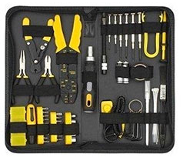
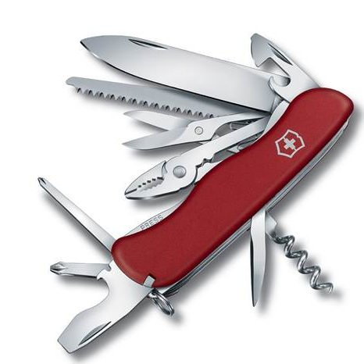

Finally a power board or double adapter for the power, there will always be a situation where you want extra power sockets or somewhere to re charge your iPhone. (Note if on holiday you forget your charger, and there are no USB recharge places available, or you forget your charger you can plug your USB cable into any smart TV USB socket and recharge from there)

The Boxes of Life

"Life is like a box of Chocolates…", from Forrest Gump, Tom Hanks

Life is made up of boxes, they can be broken into weeks, months or years, you move through life moving from box to box and there can be many boxes in your life, so you may be in a particularly bad way emotionally, financially or otherwise and you need to say to yourself, what or where will I be in one month's time, what or where will I be in three month's time, what or where will I be in one year's time, which box will I next be in…because you need to be aware that there are more boxes ahead. So move on!

Here is a sample of life's boxes
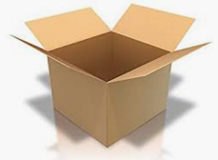
Box 1 Age 1 to 6 You will not remember much about this box but to know you are the most important person in the world. You learn about reliance, loving etc.
Box 2 Age 7 - 11 Primary School
You suddenly learn you are not the centre of the universe and need to deal with getting on with kids and having some organisation in your life, you will start to get feelings and realise that life is a sharing thing.
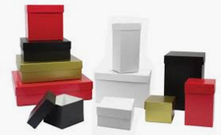
Boxes Galore, Age 12- 17 High School Here you discover emotions and bullying and friendships and your academic ability, depending on your education you might determine your future career, meet you first life long friend (remember you will only have about 3 or 4 actual life long friends that you can call on when you are in desperate need), so look after your friendships. You might be introduced to sex, drugs and alcohol and how you deal with these will move the boxes you live in around.
More Boxes Age 18 -23 University, College, a job or just loafing around will take you to a choice of several boxes, so here is a very important time in your life the average person falls in love two or three times, so there may be some emotional times and time to recall what you will be doing in 1 month, 3 months or 2 years time?
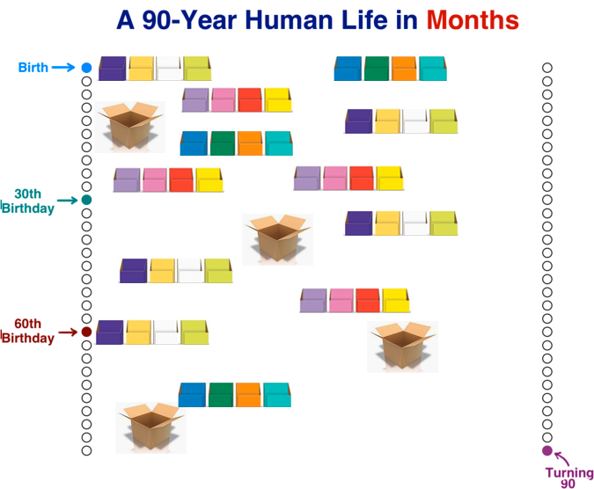So this is life moving from box to box, you may find you are in a job where the brainless idiot is your boss and you might need to plan a move to another box with a different employment opportunity, the choices are yours, so choose your boxes well but remember if this is not the right moment for you or the right direction more boxes are ahead and waiting for you… so move on.

Frame every so-called disaster with these words: “In five years, will this matter”?

Safe words for danger
Sometimes when you are out and about you need to communicate with your partners, kids or grandkids that things are not quite right and you need to evacuate the place as soon as possible. We have secret words that we use when we feel danger or feel unhappy with what is happening at the restaurant, function or venue. The word we use are ones that would not be used in normal conversation so we chose the name of Bognor Regis Butlins, so if one of us says something like "this place is not as nice as Bognor" then we trigger in that something is not quite right, if the conversation or phone call states the word Bognor and Regis we know it is time to leave. This we do without question, pay our bill and leave or just leave. If the message contains Bognor Regis Butlins we leave as quickly as possible because that is our maximum danger sentence.

First Aid
The DRSABCD action plan
If you have completed a first aid course, you will be familiar with the DRSABCD action plan.

Each letter is a prompt for the actions to take when first aid is needed.

DRSABCD ACTION PLAN

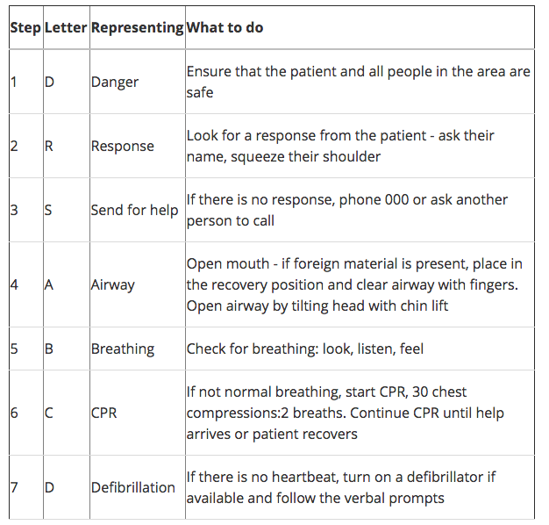

Your basic first aid kit
A basic first aid kit may contain:
- Plasters in a variety of different sizes and shapes
- Small, medium and large sterile gauze dressings
- At least 2 sterile eye dressings
- Triangular bandages
- Crêpe rolled bandages
- Safety pins
- Disposable sterile gloves
- Tweezers
- Scissors
- Alcohol-free cleansing wipes
- Sticky tape
- Thermometer (preferably digital)
- Skin rash cream, such as hydrocortisone or calendula
- Cream or spray to relieve insect bites and stings
- Antiseptic cream
- Painkillers such as paracetamol (or infant paracetamol for children), aspirin (not to be given to children under 16), or ibuprofen
- Cough medicine
- Antihistamine cream or tablets
- Distilled water for cleaning wounds
- Eye wash and eye bath
It may also be useful to keep a basic first aid manual or instruction booklet with your first aid kit.
Medicines should be checked regularly to make sure they're within their use-by dates.

Silly Cigarettes Smoking Costs

If I don't accept a cigarette I get $10,000

or I’ve been promised $10,000 if I don’t smoke

When out and about, you will most likely be offered a cigarette

Why should you refuse?

You have to understand why people offer you cigarettes in the first place, it’s probably because they feel guilty about themselves smoking and they need your support to confirm that they are not complete idiots.

When asked if I want a fag, I said no thanks I’ve been promised $10,000 if I don’t smoke. So I think I'll take the money!

They would ask how am I going to get $10,000, so I explain that if a packet of cigarettes cost $25 a week and I started smoking today I would start spending $25 a week over the next few years BUT….

I would be wasting money fags going up in smoke, causing damage to my health, and having smelly clothes and bad breath.

But if I put the $25 a week away for a year I have $25 x 52 = $1,300 saved, and If I don’t smoke for 8 years I have $10,400 I that I can give to myself.

Plus I will probably be healthier have less health bills, and also save on laundry bills to get rid of the stink of smoking.

So that is why I don't accept the ciggarette

Tobacco smoke contains more than 7,000 chemicals, including over 70 chemicals known to cause cancer (carcinogens). When you breathe in cigarette smoke, these chemicals enter your lungs and spread through your body. Most smokers are addicted to nicotine, one of the main chemicals in tobacco smoke.
Nobody expects serious smoking-related illness to happen to him or her, but it can happen to anyone. Smoking harms nearly every organ of the body and can cause many serious and disabling conditions, including 16 types of cancer, cardiovascular disease, disease and asthma.

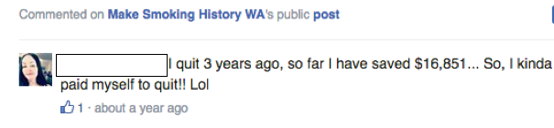

Take Drugs or get $20,000

If I don’t accept that pill or joint then I would tell myself that in a few years time I would have a gift of $20,000. Based on the scenario for smoking.

I tell people I’m very capable of my own ability to enjoy myself without any other props or needs to get me go through the night and I’m sure that if I started on the drugs I’d be a lot worse off than the $20,000 dollars I’m about to receive in a few years time, and the heath bills and impact on my life will be horrendous, and I don’t need to do anything other than to enjoy myself rely on my own ability to do just than so no thanks.

Be a millionaire by the time you are 40 (treat a joke)
It is always possible to become millionaire by the time you’re 40 you buy cheap small house near to a university college or hospital, and you should be able to rent that out and receive an income to cover the mortgage of your purchase, say your mortgage is $1000 a month you should work out you need to get 80% to 90% of this in rent (the actual return need to be about 70%), that way you will be purchasing a house for the difference between your rental income and the mortgage repayments.

A few months down the track you could use that house as collateral to purchase another house and then repeat the same scenario for the next few years by the time you’re 30 you should aim to have three houses by the time you’re 40 you should aim to our four houses and if you got four houses you should have close on $1 million in collateral, but of course it all depends on how well you look after your houses if and when you get good resale price for them. You need to get regular rent for the properties that is why they should be near a university, college or hospital, live in one bedroom for yourself and you should make some money. There are other ways but at least this is an idea.

Applying for a job

One of the hardest things you will ever do is applying for a job irrespective what trade or career you’re hoping to obtain, the first thing you need to do is make the employer want to employ you and want to interview you.

If you can get an interview then you should be able to convince the employer to take you on. To do this research your prospective employer, find out as much as you can about the company and the job vacancy.

Think outside the box when you write your letter of application, when I was a student doing a graduate diploma I attended a seminar by school principals, so I made up a letter as a scroll, stating a mature age student was completing a double major and would be a tremendous asset to any school, I put inside the scroll a mini Crunchie bar and gave each school principal a scroll saying thank you for the seminar and here is my thank you letter.

One principal told me that what I did was not acceptable but I did get two job offers later from my endeavour, ensuring that I had a teaching job before I finished university. I started at my new school at the commencement of the new term.

Your application should be written on the same lines as the company requests but do think outside of the box and add something that would make them more than interested in talking to you.

As mentioned I have done this on several occasions and worked on movie shoots, Hotel management, Office management and other stuff that I’ve had through all the jobs I've had in my life, most of which I was totally unsuited to obtain.

When you get to the interview dress appropriately and be polite smile and make eye contact as often as possible don’t forget to shake hands but this time do not kiss the cheek of any ladies. You need to act confidently and present yourself as though you know what is required to do this, the golden rule is to find out as much as you can about the company and the people you are meeting at the interview just to give you an idea of what they I’m going to be like, the more knowledge you have about the company the better chance you have securing a job. Also ask yourself the sort of questions that they might as like "why do you think you are suitable for this position?"

When you get your first job go to and buy a packet of mixed biscuits and also a selection of lollies I usually take mantis, fan tales and other lollies in wrappers these I put in a small dish on my desk so if anyone comes to talk to me they know they can take a lolly and exchange information, the biscuits you can invite someone for a coffee or you go to coffee you can take the biscuits and offer them around and anyway there are times in the day you’ll get hungry and do not wish to go rushing outside so you stay at your desk and eat a biscuit.

Be polite always treat people with respect and be as polite and nice to them as you can, you may not always feel that way but it will always work in your favour if you’re always a fairly nice person.

Also you should use good manners, open doors for ladies give up your seat for older people or ladies and smile and always have a nice thing to say. No one likes a Grinch.

Greeting people

The first rule of meeting people is never disrespect the intellectually disadvantaged when they are in a position of authority, be nice, smile, be polite to the bar staff, wait persons, door men or bouncers and you will get better service, do not use a superior attitude it will work against you. You may even get served first!

When meeting people for the first time it’s important to remember their names so when you meet somebody repeat their name to yourself three times and then try to associate then name with something familiar. Then you will be able to recall their name and recognise them as being important. For instance on the golf course when you’re introduced to your other players that you’ve not met before you would shake hands and say to yourself the names of the people your meeting and immediately use their names when replying to them thank you John thank you Dave welcome Fred.

When meeting people for the first time you should always shake their hand and if it’s a lady you have met before then you should offer to kiss their right cheek and the lady should offer their cheek to be kissed. If you have not met the lady before a simple handshake is acceptable, this is standard welcome procedure and even if you do not know the people your meeting it is wise to offer your hand in a gesture of friendship.

When people shake hands they I’m showing they have no weapons or offer any threat to the person down meeting this is a traditional that has happened over the years however it depends upon the person you are meeting for instance some other people from other countries have a different way of greeting so you must be aware of the traditions of people that you might meet for instance Japanese Eskimos or Islamic people.

The people you meeting on the most important people at that particular time in your life, make them feel important.

Try always to dictate the conversation towards what these people are about, try not to talk about yourself too much but make them feel that they are the point of the conversation.

When you meet people for the first time you must always assume that they have no colour that they are neutral in everything they do and you must make your own decision as to what sort of person they may be always send people to be at zero and then assess them either as a positive or negative this way you can form a judgement without bias and always look at the person smile and try to make eye contact in general conversation you should generally look at the persons upper lip or nose.

Starting a conversation with a stranger or strangers can difficult

To start a conversation

Some of the things you need to do are have starter lines they break the ice

For instance so how did you two meet?
Is this your first time at this event,
Where were you born?
Do you prefer old music to this modern music which era of music did you like the best?

Remember when greeting people from other countries the technique may be different to an English greeting,

When greeting someone new, always start with a firm handshake and say, “How do you do”. This is not a question; therefore expect the same response back. Another appropriate greeting is to say, “Hello, I am __________. It’s a pleasure to meet you.”

The British place considerable value on punctuality, and you should aim to arrive at the exact time suggested or a few minutes early. If invited to a home for dinner, a gift for the host is considered respectful. This is usually flowers or chocolates.

I often avoid such openings as what’s up? / What’s new?

This is a common, informal way of say “hi” and “how are you.” For “what’s up?” – in pronunciation and informal spelling (for example in texting or an informal email between friends, you might hear/see: Sup / Whassup / Whazzup Common answers include:

Not much.
Nothing.
Hey, what’s up? (Coming back at you)

I usually start with Hi, what do you know?

Yes, a bit spiky but it sets the trend that you wish to engage in conversation and avoid the negatives like - Not much etc.

Because after "not much" it would require another opening statement to continue a conversation so avoid what's up whenever you can, UNLESS you wish the exchange to be as short as possible. Other short starters include…

How’s it going? / What’s going on? / How’s everything?

These can all be simple greetings or questions similar to “How are you?” Careful! Similar to the informal situations above, the answer to these questions should usually be a simple answer. Example answers include:

Good, you?

Fine, you?

Not bad

Other people to greet

Japanese

When dealing with non-Japanese people, many Japanese will shake hands. Since many non-Japanese are familiar with the custom of bowing, this often leads to a combined bow and handshake, which can become complicated. Bows may be combined with handshakes or performed before or after shaking hands.

Thai

The Thai greeting referred to as the wai (Thai: ไหว้, pronounced [wâːj]) consists of a slight bow, with the palms pressed together in a prayer-like fashion. ... The wai is traditionally observed upon formally entering a house.

French

Kiss the cheek on their right – your left –, which is the one most commonly, kissed. If you are the one being kissed, offer your right cheek automatically. In most cases, men and women or women and women cheek kiss. Men hug or extend a hand to shake with other men.

Asians

Bows are the traditional greeting in East Asia, particularly in Japan, Korea, China, and Vietnam. In China, and Vietnam, shaking hands or a slight bow have become more popular than a full bow. However, bowing is not reserved only for greetings. Bowing is a gesture of respect.

Avoiding Starvation

Basic shopping list: - 2 litres of Milk, coffee, tea, sugar, Cornflakes, Sliced Toast Loaf, Butter, small tins of Baked Beans (4 pack), 6 eggs, small jar of jam or similar, a microwave jug or dish, a small frying pan. Knife, fork and spoons and a swiss army knife (to open cans of food). Also sandwich fillers Tuna, Cheese etc. Tomato or Cucumber, and some fruit Apples and Bananas are suitable.

Living in a dorm
Purchase a microwave you can always make a cup of tea in a microwave so by this in preference to an electric kettle and pay the extra, you can the also heat up a snack. If you have a fridge freeze your bread and just microwavefew slices for 20 secs when you want a sandwich.

Basic Menu

Breakfast:
Tea or coffee with bowl of Cornflakes or Slice of Toast

Lunch
A sandwich, and some fruit, tea coffee or soft drink

Dinner as follows =
Beans on Toast

To prevent starvation you need to have some basic knowledge of food preparation, a loaf of bread, tub of butter and a small can of baked beans will help you master the art of cooking, toast the sliced bread under a grill and watch it all the time, remove when slightly brown, spread butter and open a small tin of baked beans, put into a microwave dish and warm for 30-40 seconds serve on top of the toast.

Scramble Eggs

Toast as above, beat two or three eggs in a microwave dish then remove the fork, and place dish in microwave for 1 - 2 minutes remove stir and complete the scramble usually a few more seconds till egg is firm but moist, serve on the toast.

Studying Items

https://sensiblereviewer.com/student-survival-kit/

College or Uni study list

Make yourself a timetable, as soon as you get your unit outlines, check when all your deadlines are due and your assessments, and PLAN!

- A USB stick – You’ll be taking files to and from campus a lot, maybe one that you can pop onto a keyring might do the job to make sure you don’t forget it.
- Post-It Notes
- Folders (at least 5)
- Notebooks
- Pens
- A Laptop – Take a look at what I thought was the best laptop for under £500, and also the best budget laptops of 2015 if you’re after a new one!
- Paperclips
- Paper hole-puncher
- Stapler
- Dictaphone – This is basically a sound recorder. You can get one for as cheap as £20, and you’ll be so grateful for it when it comes to revision time and you can’t read your own notes. Make sure you get you lecturer’s permission before recording though.
- Alarm clock – To stop that ‘oh I forgot to put my phone on charge so the alarm never went off this morning’ excuse for missing lectures.
- 20p pieces – For those awful washing machines that don’t take normal change.
- Energy drinks
- Blutac
- Pins – In case you’re not allowed to bluetac things to the walls.

Living Away From home list
- A First Aid Kit – Accidents happen, it’s best to be prepared. Make sure it includes plasters.
- Paracetamol + Ibuprofen – You’ll thank me after your first night out.
- Cold + Flu Medicine – Fresher’s Flu. Especially horrible when you have lectures at the same time as Freshers week (I’m looking at you Warwick Uni…)
- Throat sweets – For the inevitable sore throat from a combination of the flu, and shouting on nights out.
- Condoms
- A pack of cards – Most of your drinking games will involve them, trust me.
- Face paint – You’ll go on so many fancy dress nights out, it’d be worth investing in an outfit too.
- Glowsticks
- Emergency £20
- Alcohol – If you’re a friend / family member, giving little shot sized bottles of spirits is a great gift idea.
- Netflix – While you’re feeling like death the day after the night before, you’ll want something to watch.
- Doorstop – Propping your door open when you first move in really helps with meeting people.
- Disinfectant wipes

Food student survival kit
- Pot Noodles – Or any cheap packet noodles, sometimes the cheaper ones taste even better.
- Tea bags / Coffee / Hot Chocolate / Sugar – If you have hot chocolate you’ll be loved by EVERYONE.
- Toaster – Could you even live without toast?
- Baked Beans – Be prepared for the last few weeks before your next student loan instalment.
- Chocolate & Biscuits
- Pasta / Rice
- Breakfast bars
- Herbs and spices – No good at cooking? It’s fine; you’ll still thank me for these when you’re struggling to make beans on toast look appetising after making them for the 9th time that week.
- A Kettle – (If you cannot afford a Microwave), unless you want to be making your tea with the saucepan, grab yourself a kettle deal quickly.
- Ready meals – Especially ones you can freeze.
- Gift voucher for the nearest supermarket – Parents, this is a great way to ensure that £20 you wanted to lend them to make sure they’re eating isn’t spent on clothes. Though you can’t make sure they don’t spend it on alcohol…

Homesick student survival kit
- A picture from home – Popping one in a frame is a nice touch.
- Letters – From close family / friends, always get them hand-written.
- Phone top-up card – If they you have a pay as you go phone.
- Skype names of family members – This will take a bit of effort to sign them all up to Skype and show them how to work a webcam and microphone beforehand, but it’ll be worth it!
- A book or teddy from childhood – You can stuff this in a drawer if you’re embarrassed, but there’ll come a time that you’ll be grateful for it.
- Motivational pictures and quotes – Extra points if the quotes are hand-written from friends and family.
- Mini box of nice chocolates

Travel Kit

- Mini manicure set
- Eye mask
- Travel toothpaste / shampoo / conditioner – For those times you run out, or get the extra fancy hair products you wouldn’t normally be able to afford for the days you need a bit of a boost.
- Makeup wipes
- Face masks
- Multivitamins
- An airer for your clothes – You’re not going to want to be known as the kid with damp, creased clothes. Buy one. Your Mum will be so proud.

Records

1. Passport
2. Driving Licence
3. NHS Number
4. Doctor’s Address
5. Room Insurance
6. Student Loan Documents
7. Bus Pass
8. Railcard
9. CV Copies
10. Passport Photos – (For Your Student ID etc)
11. Certificate Of Registration
12. Student Accommodation Documents
13. Exam Results

General stuff

1. Calendar
2. Mini Sewing Kit
3. Iron / Ironing Board
4. Games Console
5. A Fan
6. A Heater
7. Toastie Maker
8. Recipe Book
9. Playing Cards
10. Umbrella
11. Onesie
12. A Kindle – (you can find out which Kindle is the right one for you here)
13. Hot Chocolate

1. Use a budgeting tool Step one in reducing spending is to see what you’re actually spending your money on. That way you know what changes you can make to stay on budget. Download a budgeting tool such as Money Smart to plan a budget according to your income and expenditure.

6. Buy second hand books Websites such as www.studentvip.com.au is a good way to buy and sell second-hand textbooks. It’s advisable to start looking for your books a few weeks before the term starts, as stocks are limited. Alternatively, if you have friends from the same course, you could ask them if they would like to share the textbook with you. This not only saves money but also enables you to have a study buddy

Aussie Slang

ARVO
(Noun) Abbreviation of ‘afternoon’. See also: defo (definitely), servo (service station), avo (avocado) etc.
“I bumped into Johnno at the servo this arvo.”
BARBIE
(Noun) Abbreviation of ‘barbecue’; seldom used in the same sentence as ‘shrimp’.
“Let’s defo have a barbie this arvo.”
BATHERS
(Noun) A swimsuit; also ‘togs’ in Queensland and ‘swimmers’ or ‘cossies’ (abbr. of ‘swimming costume’) in New South Wales.
“Oh no, I’ve dropped avo on my bathers.”
BLOODY
(Adjective) An expression of emphasis (see also: heaps), particularly in anger.
“Oh no, I’ve dropped some bloody avo on my bathers.”
BLUDGER
(Noun) A lazy person.
“I’m running around like a headless chook organising this bloody barbie, and Johnno’s just sitting there like a bludger!”
BOGAN
(Noun) An uncouth or uncultured person. See also: feral, ratbag, reptile, bevan etc.
“I can’t understand that bogan’s broad Australian accent.”
BOTTLE-O
(Noun) Abbreviation of ‘bottle shop’, a store that sells alcohol.
“Geez there’s a lot of bogans at the bottle-o.”
BUGGER
(Noun/verb/adjective) A mild profanity that’s also one of the most versatile words in Australian English.
Exclamation; “Bugger! I dropped some more avo on myself.”
A term of sympathy; “Look at that poor bugger with avo all over his bathers.”
Tired, broken or ruined; “These bathers are buggered now.”
An annoying thing; “These avo-stained bathers a bit of a bugger.”
An impolite instruction; “Bugger off and change into some clean bathers.”
CHOCCY BIKKY
(Noun) Abbreviation of ‘chocolate biscuit’. See also: sunnies (sunglasses), undies (underwear), Crissie pressie (Christmas present) etc.
“I’m going to put my feet up this arvo with a cuppa and a choccy bikky.”
FAIR DINKUM
(Adjective) An expression used to emphasise truth or veracity.
“That choccy bikky tasted fair dinkum unbelievable.”
FOOTY
(Noun) Abbreviation of football; Australia’s favourite pastime.
“Should we invite Johnno around to watch the footy this arvo?”
GALAH
(Noun) A stupid or idiotic person; often accompanied by the adjective ‘flaming’.
“Nah mate, Johnno’s a flamin’ galah.”
GOON
(Noun) Cheap wine sold in large cartons.
“Two types of people drink goon: bogans and backpackers.”
MACCAS
(Noun) McDonalds, a popular purveyor of fast food. See also: ‘Dirty Bird’ (KFC).
“Let’s pop into Maccas after the footy.”
MATE
(Noun) Friend; used in a variety of different contexts.
Addressing an actual friend: “G’day, mate.”
Addressing an enemy: “Listen here, mate…”
Expression of congratulations: “Maaate!”
Expression of indignation: “Aw, mate…”
Expression of surprise: “Mate!”
Expression of scepticism: “Maaate…”
SHOUT
(Noun) A round of drinks at a bar; nothing to do with raising one’s voice.
“It’s Johnno’s shout, the bludger.”
SNAG
(Noun) Sausage – a cylinder of processed meat that represents Australia’s richest culinary tradition.
“I asked Johnno to pick up some snags for the barbie this arvo, but the galah forgot.”
THONGS
(Noun) Sandals or ‘flip-flops’, wedged between one’s toes rather than one’s arse cheeks.
“Bogans always wear thongs.”
U-EY
(Noun) (Pronounced: yoo-ee) A U-turn; changing the direction of a vehicle 180 degrees.
“Chuck a u-ey” (i.e. “Perform a U-turn”).
WOOP WOOP
(Noun) The remote outback.
“If this galah doesn’t chuck a u-ey soon we’re going to end up in Woop Woop.”

